**Final Photos for Web Pages** 8-2013

**Welcome Page**

1. What We Treat



1. About Dr. Miller



1. Get Started

[](http://us.fotolia.com/id/48102440)

**What We Treat Page**

[](http://us.fotolia.com/id/37358770)

1. Depression & Grief

[](http://us.fotolia.com/id/49225283)

1. Anxiety, Worry & Fear



1. Sleep Disorders



1. Life Transition Challenges

[](http://us.fotolia.com/id/51648294)

1. Purpose, Meaning and Self-Identity

[](http://us.fotolia.com/id/53104932)

1. Sexual & Intimacy Concerns



1. Marital & Partner Conflict & Despair

[](http://us.fotolia.com/id/46828069)

1. Infidelity Challenges

[](http://us.fotolia.com/id/53295679)

1. Marital Separation & Divorce Distress

[](http://us.fotolia.com/id/54267123)

1. Relationship Doldrums & Apathy

[](http://us.fotolia.com/id/49913651)

1. Stress from Chronic & Terminal Illness

[](http://us.fotolia.com/id/42170822)

1. Men’s Issues

[](http://us.fotolia.com/id/6069249)

1. Parenting, Step-Parenting & Co-Parenting Issues

[](http://us.fotolia.com/id/24107292)

1. Caregiver Stress



1. Business Performance Coaching



**Specialty Services**

[](http://us.fotolia.com/id/35936758) 

**About**

1. Resiliency Center

[](http://www.google.com/imgres?sa=X&rlz=1T4MXGB_enUS512US512&biw=1488&bih=865&tbm=isch&tbnid=A3BSbCWzgED17M:&imgrefurl=http://pinnaclecapitalmortgageblog.wordpress.com/2012/04/21/asking-prices-rising-in-phoenix-2/&docid=ENvxUm1w2r1XRM&imgurl=http://pinnaclecapitalmortgageblog.files.wordpress.com/2012/04/phoenix.jpg&w=300&h=321&ei=rADrUeTjO4HG9gT954DABA&zoom=1&ved=1t:3588,r:67,s:0,i:290&iact=rc&page=3&tbnh=193&tbnw=184&start=65&ndsp=38&tx=150&ty=152) [](http://us.fotolia.com/id/33185814) 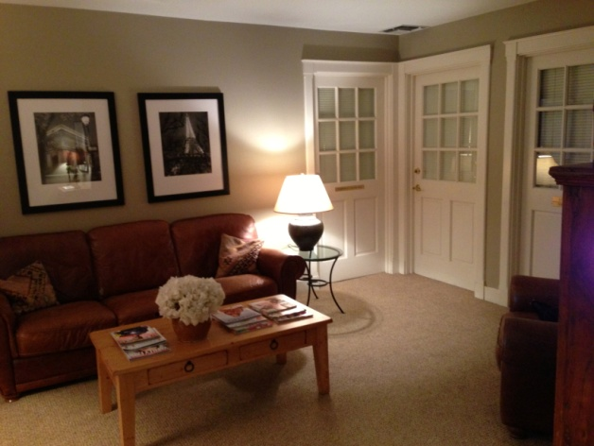

1. Dr. Revel Miller’s Background

  

1. Fees & Insurance

[](http://us.fotolia.com/id/14365815)

**Get Started**

1. Steps to Take



1. Your Helpful Forms Are Here

[](http://us.fotolia.com/id/44741573)

1. Your First Four Sessions

[](http://us.fotolia.com/id/48488352)

**For Professionals**

1. Collaboration with Health Professionals

[](http://us.fotolia.com/id/33108639)

1. Collaboration with Legal Professionals

[](http://us.fotolia.com/id/485663)

**Resources**

[](http://us.fotolia.com/id/2544729)

1. Articles

[](http://us.fotolia.com/id/53837789)

1. Books

[](http://us.fotolia.com/id/45917188)

1. Website Links

[](http://us.fotolia.com/id/53494755)

**FAQ**

[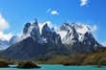](http://us.fotolia.com/id/51408261)

**Contact**

I will send photo of exterior façade of office & Parking area

**Right Side-Bar Images**

[](http://www.google.com/imgres?sa=X&rlz=1T4MXGB_enUS512US512&biw=1488&bih=865&tbm=isch&tbnid=A3BSbCWzgED17M:&imgrefurl=http://pinnaclecapitalmortgageblog.wordpress.com/2012/04/21/asking-prices-rising-in-phoenix-2/&docid=ENvxUm1w2r1XRM&imgurl=http://pinnaclecapitalmortgageblog.files.wordpress.com/2012/04/phoenix.jpg&w=300&h=321&ei=rADrUeTjO4HG9gT954DABA&zoom=1&ved=1t:3588,r:67,s:0,i:290&iact=rc&page=3&tbnh=193&tbnw=184&start=65&ndsp=38&tx=150&ty=152) above

[](http://us.fotolia.com/id/33185814)Below